Developing Strategic Leaders Programme (Southeast/Southwest)
Guidance for Chief Executives on the nomination process for the 2025/26 cohort

The brand-new Developing Strategic Leaders Programme delivered by the Leadership Centre in partnership with SOLACE is aimed at aspiring leaders with the ambition to develop their strategic thinking and leadership. There will be cohorts in both the Southwest and Southeast regions that will run in parallel between June 2025 and March 2026.

Chief Executives are invited to nominate up to two people from their authority to be part of this first cohort. The target group is people currently in a permanent or interim Head of service Role whose next step would be into a Director post.

The diagram below suggests the selection criteria that you might use in making a nomination. Furthermore, it’s vital that the person has a keen interest in joining the programme and that they are sponsored by you.
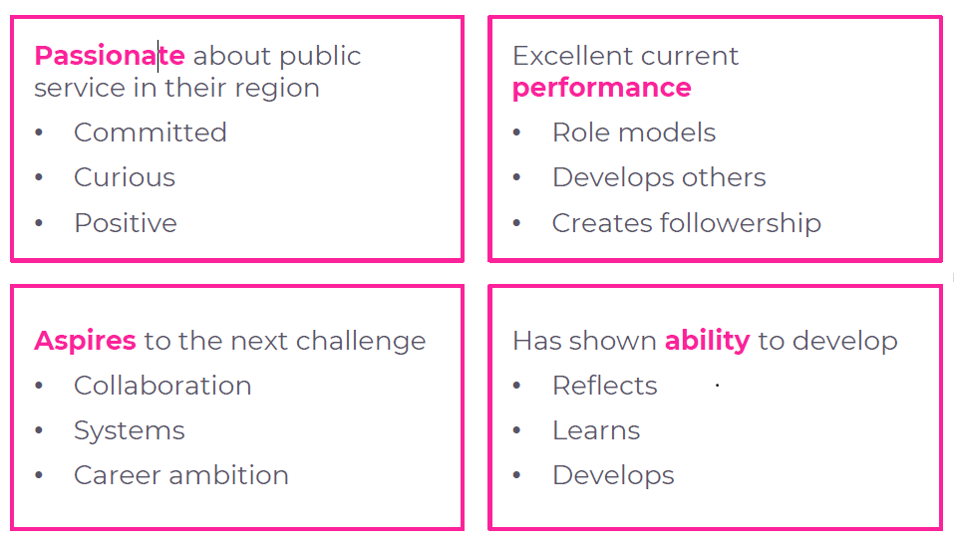
The interconnection between the criteria above are important, as individuals will vary in their motivations and the extent to which they display evidence of each criteria. Some may be looking for promotion, others may be looking to broaden their experience and skills by collaboration outside the authority, others may underestimate their potential and need encouragement.

The cost per participant is £2,985 + VAT payable to the Leadership Centre.
This includes all meals and refreshments (travel is not included but all venues will be within the region). The attached brochure gives further details about the Developing Strategic Leaders Programme and is for circulation to those who the authority is considering.

Please work with your nominees to complete and return the attached nomination form completing the Chief Executive’s endorsement supporting statement indicating why this person has been chosen and how you are going to support them during the programme and return the form to: learning@solace.org.uk by no later than 30th May 2025.

